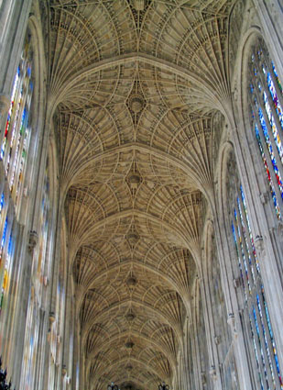
From Byrd to Broadway – and beyond!

A concert of a capella close harmony singing from five centuries

The King’s Men

Adult Choral Scholars of the Choir of King’s College, Cambridge

Promoted by the Lunar Society, supporting Ammalife
“Saving mothers’ lives worldwide”

Birmingham Cathedral, Colmore Row
7.30pm, Thursday 27 March 2014
Tickets (including an interval drink):
£15 Ground floor; £12 Galleries

ADVANCE BOOKING ESSENTIAL
Contact: kingsmen@lunarsociety.org.uk

Booking form (return to e-mail above or address for cheques below)

Name: …………………………………………………………………….
Address for tickets: ………………..………………………………………. ………………………………………………………………………………..
Tickets required:
Ground floor: …. tickets @ £15 ……………Subtotal: … £
Gallery: …. tickets @ £12 ……………Subtotal: … £
TOTAL: £
Do you require wheelchair access? (Ground floor only) YES/NO

Payment
By BACS to The Lunar Society (Sort 20-07-82, Account 53728358)
please use your name as a reference when making the payment; return form by e-mail to kingsmen@lunarsocieety.org.uk, or by post to address below
Or by cheque payable to the Lunar Society (send cheque + form to Alan Wenban-Smith, 48 St Agnes Road, Birmingham B13 9PN)

FURTHER DETAILS
Artists
The King’s Men is a close harmony group of adult Choral Scholars from the Choir of King’s College, Cambridge (famous for its broadcast Carol services at Christmas). As well as pursuing their undergraduate studies and singing for Chapel services throughout term, the King’s Men find time for a busy concert and recording schedule in the UK and around the world, winning golden tributes (for more go to www.kingsmencambridge.co.uk).

"luxurious blend of voices" The Times; "Virtuosic singing" BBC Music

Ammalife (UK Reg Charity 1120236)
A contribution from the sale of every ticket will go to support the medical charity Ammalife. Founded in Birmingham only six years ago, Ammalife is devoted to reducing the unacceptable suffering and loss of life in childbirth in low income countries, focusing on practical healthcare for mothers. Ammalife’s research has already attracted attention from the World Health Organisation, and it is trialling evidence-based ideas in local partnerships in Pakistan and Malawi. To see what Ammalife does in more depth and detail visit www.ammalife.org.

The concert
The Lunar Society (www.lunarsociety.org.uk) has arranged for the King’s Men to include Birmingham on their 2014 UK Spring tour. They are offering an extraordinary repertoire, ranging from sacred music of the early renaissance through traditional, folk and spiritual to Broadway shows and pop. Much of this material has been arranged by the singers themselves. Birmingham’s St Philip’s Cathedral has superb acoustics and ambience, and will provide a magnificent setting for a unique musical experience.

Booking
Prices will be £15 for ground floor seating (wheelchair accessible) and £12 for the galleries (access only by stairs requiring a degree of nimbleness, with excellent sight lines in the front row, but more limited elsewhere). Ticket prices include an interval drink (wine, water or a soft drink). Payment is by BACS or cheque to the Lunar Society. Return booking form (opposite) to kingsmen@lunarsociety.org.uk, or send to Alan Wenban-Smith, 48 St Agnes Road, Birmingham B13 9PN.

